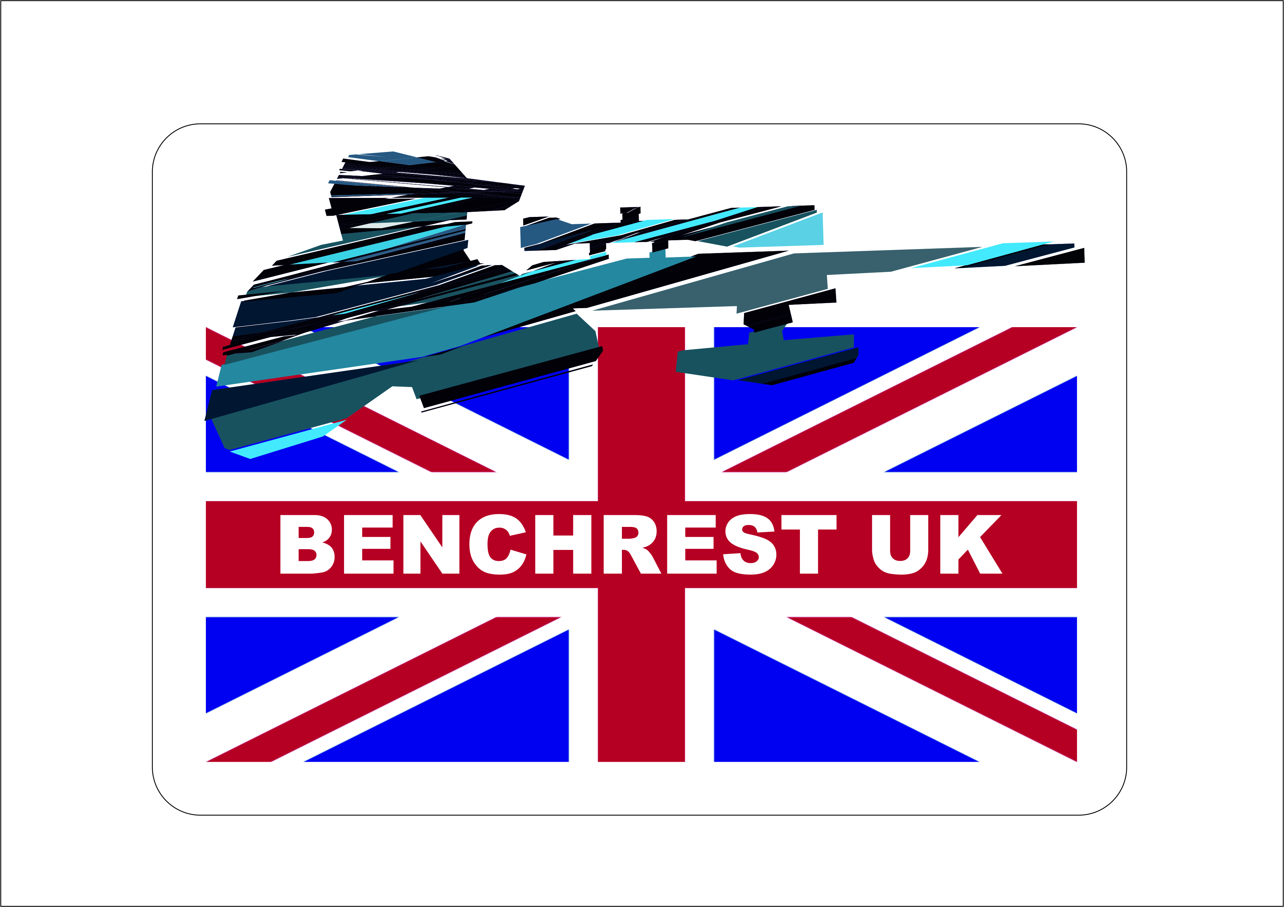

BENCHREST UK POSTAL COMPETITION RULES

FORMAT
THERE WILL BE 10 TARGETS SHOT OVER THE PERIOD OF 10 MONTHS STARTING FROM MARCH. THESE CAN BE SHOT INDOOR OR OUTDOOR DEPENDING ON THE CLASS OR CLASSES YOU HAVE CHOSEN TO COMPETE IN.
TARGETS MUST BE SHOT OVER A DISTANCE OF 25 METRES / YARDS FOR AIR AND 25 / 50 METRES / YARDS FOR RIMFIRE IN A 20 MINUTE DETAIL. AIR RIFLE CAN BE SHOT .177 OR .22 CALIBRE.
TARGETS WILL BE SENT OUT TO CLUBS IN ADVANCE OF THE START OF THE COMPETITION AND WILL BE PRE NAMED, DATED AND STAMPED.
TARGETS WILL BE SCORED BY A DESIGNATED SCORER WITHIN YOUR CLUB AND SCORES WILL BE EMAILED TO THE BENCHREST UK POSTAL COMPETITIONS SECRETARY USING THE SUPPLIED TEMPLATE ON THE WEBSITE. TARGETS SHOULD BE RETAINED BY THE CLUB UNTIL THE END OF THE COMPETITIONS AS THE COMPETITION SECRETARY MAY REQUEST A SAMPLE TO VERIFY ACCURACY OF MARKING. ALL TARGETS WILL BE SCORED USING A .224 BENCHREST UK GAUGE AND PLUGGED IF NEEDED.
RESULTS WILL BE PLACED ON THE BENCHREST UK WEBPAGE AND MEDALS WILL BE ISSUED DOWN TO THIRD PLACE IN EACH CLASS.
EACH CLASS DEPENDING ON COMPETITOR NUMBERS WILL BE SPLIT INTO 2 CLASSES A & B. MEDALS WILL BE ISSUED DOWN TO THIRD PLACE IN EACH CLASS.

RULES
TO SHOOT THE POSTAL COMPETITION YOU ARE REQUIRED TO BE A MEMBER OF BENCHREST UK. CLICK HERE https://www.benchrestuk.com/?page_id=735
CLASSES WILL BE AS FOLLOWS
RIMFIRE – 25M/YDS INDOOR LR & HR
-50M/YDS OUTDOOR LR & HR
AIR RIFLE - 25M/YDS INDOOR LR & HR-SUB12
-25M/YDS OUTDOOR LR & HR-SUB12
AIR RIFLE -25M/YDS OUTDOOR HR-20FLBS
AIR RIFLE -50M/YDS OUTDOOR UNLIMITED AIR
ONE TARGET IS TO BE SHOT EACH MONTH FOR EACH CLASS YOU ARE SHOOTING. THESE TARGETS ARE TO BE SHOT WITH A RANGE OFFICER OR CLUB MEMBER PRESENT AND SIGNED AND DATED BY THAT MEMBER IN THE PROVIDED SPACE.YOU WILL HAVE A MAXIMUM OF 20 MINUTES TO COMPLETE YOUR TARGET.THE TARGETS SHOULD BE SCORED BY YOUR DESIGNATED CLUB SCORER USING A .224 BENCHREST UK GAUGE.

SCORES MUST BE EMAILED THROUGH AND RECEIVED BY THE BENCHREST UK POSTAL COMPETITIONS SECRETARY WITHIN 14 DAYS AFTER THE END OF THE MONTH THE TARGET WAS DUE TO BE SHOT IN. IE MARCH’S TARGET SCORE SHOULD BE IN BY THE 14TH APRIL. IF YOU FAIL TO DO THIS THE SCORE FOR THAT TARGET WILL NOT COUNT TOWARDS YOUR TOTAL SCORE AT THE END OF THE COMPETITION.

IN THE EVENT OF A DISPUTE OVER SCORING OR ANY OTHER MATTER RELATED TO THE BENCHREST UK POSTAL COMPETITIONS THE COMPETITION SECRETARY WILL IN THE FIRST INSTANCE, SEEK TO RESOLVE THE ISSUE WITH THE CLUB AND / OR THE INDIVIDUAL CLUB MEMBER. IF THE ISSUE CANNOT BE RESOLVED IN THIS WAY, THE COMPETITION SECRETARY WILL CONSULT WITH THE BENCHREST UK COMMITTEE BEFORE NOTIFYING OF HIS / HER DECISION. ANY DISCREPANCIES SHOULD BE NOTIFIED WITHIN 48 HRS OF THE TARGETS BEING RECEIVED, TARGETS WILL NOT BE REPLACED THERE AFTER

EQUIPMENT

FRONT REST
YOU CAN SHOOT EITHER USING A FRONT REST OR BIPOD OR ANY OTHER PEDESTAL SUPPORT AS LONG AS IT INCORPORATES A PLYABLE SAND BAG IN WHICH THE GUN IS RESTED ON. THE GUN CANNOT BE CLAMPED OR FIXED IN ANY WAY IN THIS REST AND IF LIFTED MUST COME OUT CLEANLY AND BE ABLE TO MOVE BACK AND FORTH EASILY. THERE IS NO WEIGHT LIMIT ON THE REST. IF USING A BIPOD IT MUST BE WEIGHED ON THE GUN AND WILL BE INCLUDED IN THE OVERALL WEIGHT OF THE GUN FOR THE APPROPRIATE CLASS YOU ARE SHOOTING.
REAR REST
AT THE STOCK END OF THE GUN YOU CAN EITHER USE A CONVENTIONAL SAND FILLED BACK BAG OR YOU CAN SHOOT USING A GLOVE OR THE GUN CAN BE SHOULDERED AS LONG AS IT REMAINS ON AND IN CONTACT WITH THE FRONT PEDESTAL SUPPORT. YOU CANNOT USE A CONJOINED FRONT AND BACK REST OR ONE THAT CONTAINS HORIZONTAL OR VERTICAL ADJUSTMENT. THE REAR BAG CANNOT BE CONTAINED IN ANY WAY. YOU ARE NOT ALLOWED TO FIX /CLAMP ANY OF YOUR EQUIPMENT TO THE BENCH.

RIFLE CLASSIFICATIONS
LIGHT RIFLE ( WEIGHT UP TO 10.8 LBS ) (LR) RIMFIRE
HEAVY RIFLE ( WEIGHT UP TO 15 LBS ) (HR) RIMFIRE
LIGHT RIFLE ( WEIGHT UP TO 10.8 LBS ) (LR) AIR RIFLE SUB-12
HEAVY RIFLE ( WEIGHT UP TO 15 LBS ) (HR) AIR RIFLE SUB-12
HEAVY RIFLE ( WEIGHT UP TO 15 LBS ) (HR) AIR RIFLE 20 FLBS
LIGHT RIFLES CAN BE USED FOR BOTH LR / HR
UNLIMITED AIR CLASS (NO WEIGHT OR POWER RESTRICTIONS )
IF YOU ARE SHOOTING EITHER THE HEAVY RIFLE 20 FTLB OR THE UNLIMITED AIR YOU MUST HAVE YOUR AIR RIFLE REGISTERED AS A FIREARM ON YOUR FAC LICENCE IN ACCORDANCE WITH UK FIREARM LAWS

RIFLE CLASSIFICATIONS ALL AS THE WORLD & RIMFIRE & AIR RIFLE BENCHREST RULES 2023-2029
http://www.wrabf.com
https://www.benchrestuk.com/?page_id=277

TARGETS
TARGETS TO BE USED IN THIS COMPETITION WILL BE OFFICAL BENCHREST UK 25M /YDS AND 50M /YDS TARGETS WHICH HAVE BEEN ISSUED WITH THE SHOOTERS NAME AND STAMPED, NO OTHER TARGETS WILL NOT BE ACCEPTED AND SHOULD NOT BE SCORED BY A DESIGNATED SCORER WITHIN YOUR CLUB

Benchrest uk 25m
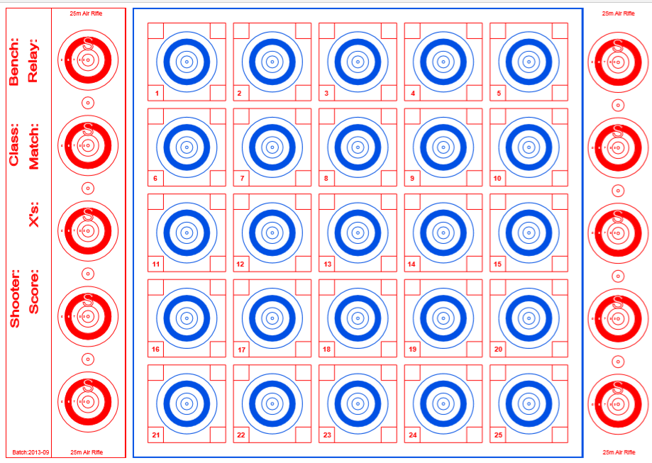
Benchrest uk 50m
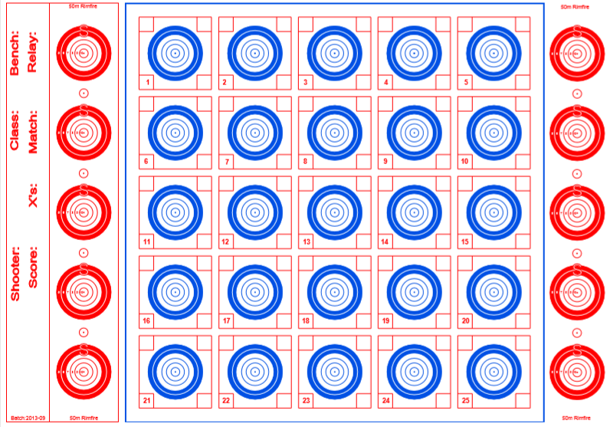

SCORING
BEST EDGE SCORING WILL BE USED IN SCORING BENCHREST UK TARGETS
ALL SHOTS WHICH CANNOT BE SCORED BY VISUAL SCORING WILL BE CHECKED USING A CERTIFIED .224 PLUG AND THE TARGET WILL BE MARKED WITH A “P” TO INDICATE THAT IT HAS BEEN PLUGGED.
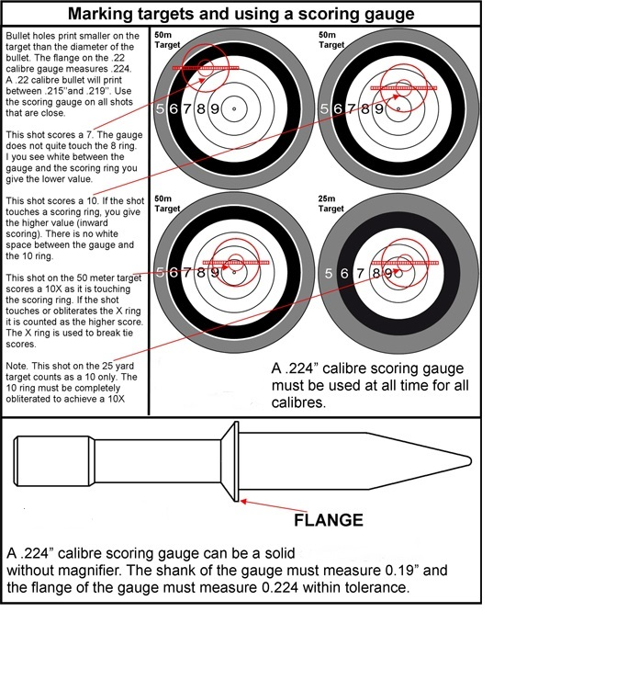

WIND FLAGS
WHEN SHOOTING OUTSIDE WIND FLAGS MAY BE USED
WIND FLAGS MUST NOT BE HIGHER THAN THE BOTTOM OF THE BENCHREST UK TARGET
NO EXTERNAL ELECTRONIC WIND FLAGS

RIFLES
- Light Rifle Air Rifle Class.
AIR LR is any rifle having only manually and mechanically operated firing mechanism, weighing not more than 10 1/2 pounds (4.762 kg+28gr allowance = 4.79Kg) inclusive of sight. Factory stock or stocks that meet ‘Stock Clarification’ rules may be used (see APPENDIX F). The action can be either spring or pneumatic; air regulators, barrel weights, harmonic tuners or bullet stabilisers are permitted but will be included in the overall weight of gun. Air regulators can be used if it is integral within the air rifle. Any magnification scope may be used. The barrel/ action can be bedded and have the trigger reworked (or replaced). Power to be restricted to 16.27 Joules or 12ft lbs. maximum. gauge). Build in electronic triggers are allowed however, mechanically, or electronically external assisted triggers are not allowed. Electronic triggers must be part and build into the rifle and no external assisted triggers are allowed. Stock tape is permitted. Magazines are allowed
- Heavy RIfle Air Rifle12ft lbs.
AIR HR is any rifle having only manually and mechanically operated firing mechanism, a weight restriction of 15lbs is set (6.803kg+28gram allowance = 6.831kg) (including attachments – scopes, muzzle devices, etc.). Factory stock or stocks that meet ‘Stock Clarification’ rules may be used (see APPENDIX F). Any manual modification may be made to the rifle and any magnification scope may be used. Air regulators can be used as long as it is integral within the air rifle. Muzzle brakes, muzzle flips, barrel weights or Harmonic Tuners are permitted. There is no restriction on cylinder size or capacity as long as
12ft lbs. maximum power is retained and it is integral within the rifle. (Separate Air Cylinders are not allowed, the cylinder must be part of the rifle and the overall weight). Electronic triggers are allowed however, mechanically, or electronically external assisted triggers are not allowed. Electronic triggers must be part and build into the rifle and no external assisted triggers are allowed. Stock tape is permitted. Magazines are allowed.
(BA) Heavy RIfle Air Rifle 20ft lbs..
AR HR is any rifle having only manually and mechanically operated firing mechanism, a weight restriction of 15lbs is set (6.803kg+28gram allowance = 6.831kg) (including attachments – scopes, muzzle devices, etc.). Factory stock or stocks that meet ‘Stock Clarification’ rules may be used (see APPENDIX F). Any manual modification may be made to the rifle and any magnification scope may be used. Air regulators can be used as long as it is integral within the air rifle. Muzzle brakes, muzzle flips, barrel weights or Harmonic Tuners are permitted. There is no restriction on cylinder size or capacity as long as 27.12 Joules or 20ft lbs. maximum power is retained and it is integral within the rifle. (Separate Air Cylinders are not allowed, the cylinder must be part of the rifle and the overall weight). Electronic triggers are allowed however, mechanically, or electronically external assisted triggers are not allowed. Electronic triggers must be part ++and build into the rifle and no external assisted triggers are allowed. Stock tape is permitted. Magazines are allowed.
- Unlimited air Rifle Class – 50m.
The purpose of this class is to have an open class where weight, energy, speed, and stock rules do not apply. It is any rifle having a manually, mechanically, or electronically operated firing mechanism. Any air rifle caliber up to 5.5mm can be used. Both pellets and slugs can be used. Build in electronic triggers are allowed and no external electronic triggers are allowed. The rifle can be shot from a front and back rest, bipod, or X-bag. Magazines are allowed. Silencers/ suppressors are allowed. There is no restriction on air rifle air cylinder size or capacity that is fitted to the rifle. Tethering is allowed, permitted it can be done safely using a buddy bottle of max 3l (liters). Tethering is the permanent connection of air supply such as buddy bottle to the air cylinder of an Air Rifle. A fixed connection is made between the air cylinder of the rifle to the external air supply reservoir
APPENDIX F Stocks Clarification International Sporter Class. The action may be glued into the stock. Stock must be 57.15 mm (2.25") under at its widest point. No stock tape allowed. For-end and butt of stock that come in contact with front and rear sandbags must be flat OR convex. The stock width can be maximum 57.15mm (2.25”). The stock must measure 57.15mm for the first 5” of the stock measured from the front end of the stock. The remainder of the stock can be of any width. The stock can be a specialist stock or via a flat plate attached to the bottom of the stock, any material can be used. The bottom of the butt of the stock that comes in contact with rear sandbag must be either convex or flat. If flat the bottom of the butt of stock must be 25mm (0.98") or under in width. The motivation for the first 5” to be 57.15mm and the remainder of the stock of any width is that the width of the remainder of the stock will give a competitor no competitive advantage. Many rifle stocks are wider towards the action to support the action The rifle must remain within the weight limit for the class. The front part of the stock that rests on the front rest must by 57.15mm 10.5lb Light Rifle and Heavy Rifle Weight Classes (Including Air Rifles), The forearm of stock must be either convex or flat. The stock width can be maximum 76.2mm (3"). The stock must measure 76.2mm for the first 5” of the stock measured from the front end of the stock. The remainder of the stock can be of any width. The stock can be a specialist stock or via a flat plate attached to the bottom of the stock, any material can be used. The bottom of the butt of the stock that comes in contact with rear sandbag must be either convex or flat. If flat the bottom of the butt of stock must be 25mm (0.98") or under in width. The motivation for the first 5” to be 76.2mm and the remainder of the stock of any width is that the width of the remainder of the stock will give a competitor no competitive advantage. Many rifle stocks are wider towards the action to support the action. The rifle must remain within the weight limit for the class. The front part of the stock that rests on the front rest must by 76.2mm. It is the responsibility of the individual competitor to check they abide by these specifications.
REVISED 17/11/2023

