

BENCHREST UK POSTAL COMPETITION RULES

FORMAT
THERE WILL BE 10 TARGETS SHOT OVER THE PERIOD OF 10 MONTHS STARTING FROM MARCH. THESE CAN BE SHOT INDOOR OR OUTDOOR DEPENDING ON THE CLASS OR CLASSES YOU HAVE CHOSEN TO COMPETE IN.
TARGETS MUST BE SHOT OVER A DISTANCE OF 25 METRES / YARDS FOR AIR AND 25 / 50 METRES / YARDS FOR RIMFIRE IN A 20 MINUTE DETAIL. AIR RIFLE CAN BE SHOT .177 OR .224 CALIBRE.
TARGETS WILL BE SENT OUT TO CLUBS IN ADVANCE OF THE START OF THE COMPETITION AND WILL BE PRE NAMED, DATED AND STAMPED.
TARGETS WILL BE SCORED BY A DESIGNATED SCORER WITHIN YOUR CLUB AND SCORES WILL BE EMAILED TO THE BENCHREST UK POSTAL COMPETITIONS SECRETARY USING THE SUPPLIED TEMPLATE ON THE WEBSITE. TARGETS SHOULD BE RETAINED BY THE CLUB UNTIL THE END OF THE COMPETITIONS AS THE COMPETITION SECRETARY MAY REQUEST A SAMPLE TO VERIFY ACCURACY OF MARKING. ALL TARGETS WILL BE SCORED USING A .224 BENCHREST UK GAUGE AND PLUGGED IF NEEDED.
RESULTS WILL BE PLACED ON THE BENCHREST UK WEBPAGE AND MEDALS WILL BE ISSUED DOWN TO THIRD PLACE IN EACH CLASS.
EACH CLASS DEPENDING ON COMPETITOR NUMBERS WILL BE SPLIT INTO 2 CLASSES A & B MEDALS WILL BE ISSUED DOWN TO THIRD PLACE IN EACH CLASS.

RULES
TO SHOOT THE POSTAL COMPETITION YOU ARE REQUIRED TO BE A MEMBER OF BENCHREST UK.
CLASSES WILL BE AS FOLLOWS
RIMFIRE – 25M/YDS INDOOR LV & HV
-50M/YDS OUTDOOR LV & HV
AIR RIFLE - 25M/YDS INDOOR LV & HV-SUB12
-25M/YDS OUTDOOR LV & HV-SUB12
ONE TARGET IS TO BE SHOT EACH MONTH FOR EACH CLASS YOU ARE SHOOTING. THESE TARGETS ARE TO BE SHOT WITH A RANGE OFFICER OR CLUB MEMBER PRESENT AND SIGNED AND DATED BY THAT MEMBER IN THE PROVIDED SPACE.YOU WILL HAVE A MAXIMUM OF 20 MINUTES TO COMPLETE YOUR TARGET.THE TARGETS SHOULD BE SCORED BY YOUR DESIGNATED CLUB SCORER USING A .224 BENCHREST UK GAUGE.

SCORES MUST BE EMAILED THROUGH AND RECEIVED BY THE BENCHREST UK POSTAL COMPETITIONS SECRETARY WITHIN 14 DAYS AFTER THE END OF THE MONTH THE TARGET WAS DUE TO BE SHOT IN. IE MARCH’S TARGET SCORE SHOULD BE IN BY THE 14TH APRIL. IF YOU FAIL TO DO THIS THE SCORE FOR THAT TARGET WILL NOT COUNT TOWARDS YOUR TOTAL SCORE AT THE END OF THE COMPETITION.

IN THE EVENT OF A DISPUTE OVER SCORING OR ANY OTHER MATTER RELATED TO THE BENCHREST UK POSTAL COMPETITIONS THE COMPETITION SECRETARY WILL IN THE FIRST INSTANCE, SEEK TO RESOLVE THE ISSUE WITH THE CLUB AND / OR THE INDIVIDUAL CLUB MEMBER. IF THE ISSUE CANNOT BE RESOLVED IN THIS WAY, THE COMPETITION SECRETARY WILL CONSULT WITH THE BENCHREST UK COMMITTEE BEFORE NOTIFYING OF HIS / HER DECISION. ANY DISCREPANCIES SHOULD BE NOTIFIED WITHIN 48 HRS OF THE TARGETS BEING RECEIVED, TARGETS WILL NOT BE REPLACED THERE AFTER

EQUIPMENT

FRONT REST
YOU CAN SHOOT EITHER USING A FRONT REST OR BIPOD OR ANY OTHER PEDESTAL SUPPORT AS LONG AS IT INCORPORATES A PLYABLE SAND BAG IN WHICH THE GUN IS RESTED ON. THE GUN CANNOT BE CLAMPED OR FIXED IN ANY WAY IN THIS REST AND IF LIFTED MUST COME OUT CLEANLY AND BE ABLE TO MOVE BACK AND FORTH EASILY. THERE IS NO WEIGHT LIMIT ON THE REST. IF USING A BIPOD IT MUST BE WEIGHED ON THE GUN AND WILL BE INCLUDED IN THE OVERALL WEIGHT OF THE GUN FOR THE APPROPRIATE CLASS YOU ARE SHOOTING.
REAR REST
AT THE STOCK END OF THE GUN YOU CAN EITHER USE A CONVENTIONAL SAND FILLED BACK BAG OR YOU CAN SHOOT USING A GLOVE OR THE GUN CAN BE SHOULDERED AS LONG AS IT REMAINS ON AND IN CONTACT WITH THE FRONT PEDESTAL SUPPORT. YOU CANNOT USE A CONJOINED FRONT AND BACK REST OR ONE THAT CONTAINS HORIZONTAL OR VERTICAL ADJUSTMENT. THE REAR BAG CANNOT BE CONTAINED IN ANY WAY. YOU ARE NOT ALLOWED TO FIX /CLAMP ANY OF YOUR EQUIPMENT TO THE BENCH.

RIFLE CLASSIFICATIONS
LIGHT VARMINT (LV) RIMFIRE
HEAVY VARMINT (HV) RIMFIRE
LIGHT VARMINT (LV) AIR RIFLE SUB-12
HEAVY VARMINT (HV) AIR RIFLE SUB-12
RIFLE CLASSIFICATIONS ALL AS THE WORLD & RIMFIRE & AIR RIFLE BENCHREST RULES 2013-2021
http://www.wrabf.com
https://www.benchrestuk.com/?page_id=277

TARGETS
TARGETS TO BE USED IN THIS COMPETITION WILL BE OFFICAL BENCHREST UK 25M /YDS AND 50M /YDS TARGETS WHICH HAVE BEEN ISSUED WITH THE SHOOTERS NAME AND STAMPED, NO OTHER TARGETS WILL NOT BE ACCEPTED AND SHOULD NOT BE SCORED BY A DESIGNATED SCORER WITHIN YOUR CLUB

Benchrest uk 25m
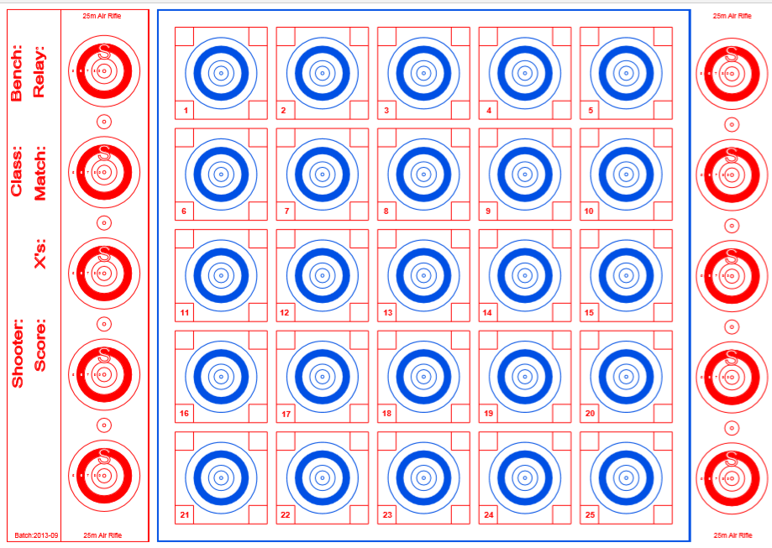
Benchrest uk 50m
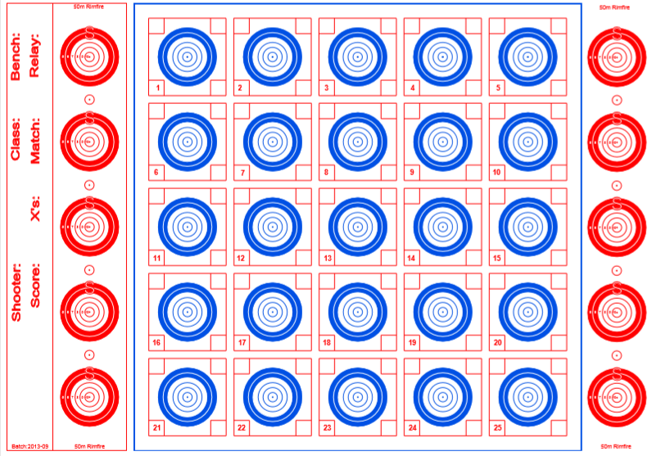

SCORING
BEST EDGE SCORING WILL BE USED IN SCORING BENCHREST UK TARGETS
ALL SHOTS WHICH CANNOT BE SCORED BY VISUAL SCORING WILL BE CHECKED USING A CERTIFIED .224 PLUG AND THE TARGET WILL BE MARKED WITH A “P” TO INDICATE THAT IT HAS BEEN PLUGGED.
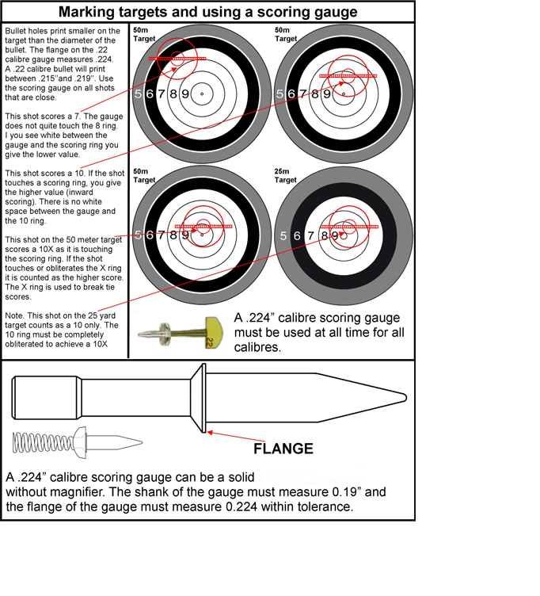

WIND FLAGS
WHEN SHOOTING OUTSIDE WIND FLAGS MAY BE USED
WIND FLAGS MUST NOT BE HIGHER THAN THE BENCHREST BENCH TOP TO THE BOTTOM OF THE BENCHREST UK TARGET
THE USE OF ELECTRONICS IN ALL FORMS IS STRICTLY PROHIBITED IN ALL RIFLE CLASSES AND THIS INCLUDES ELCTRONIC WIND FLAGS

REVISED 25/2/23

