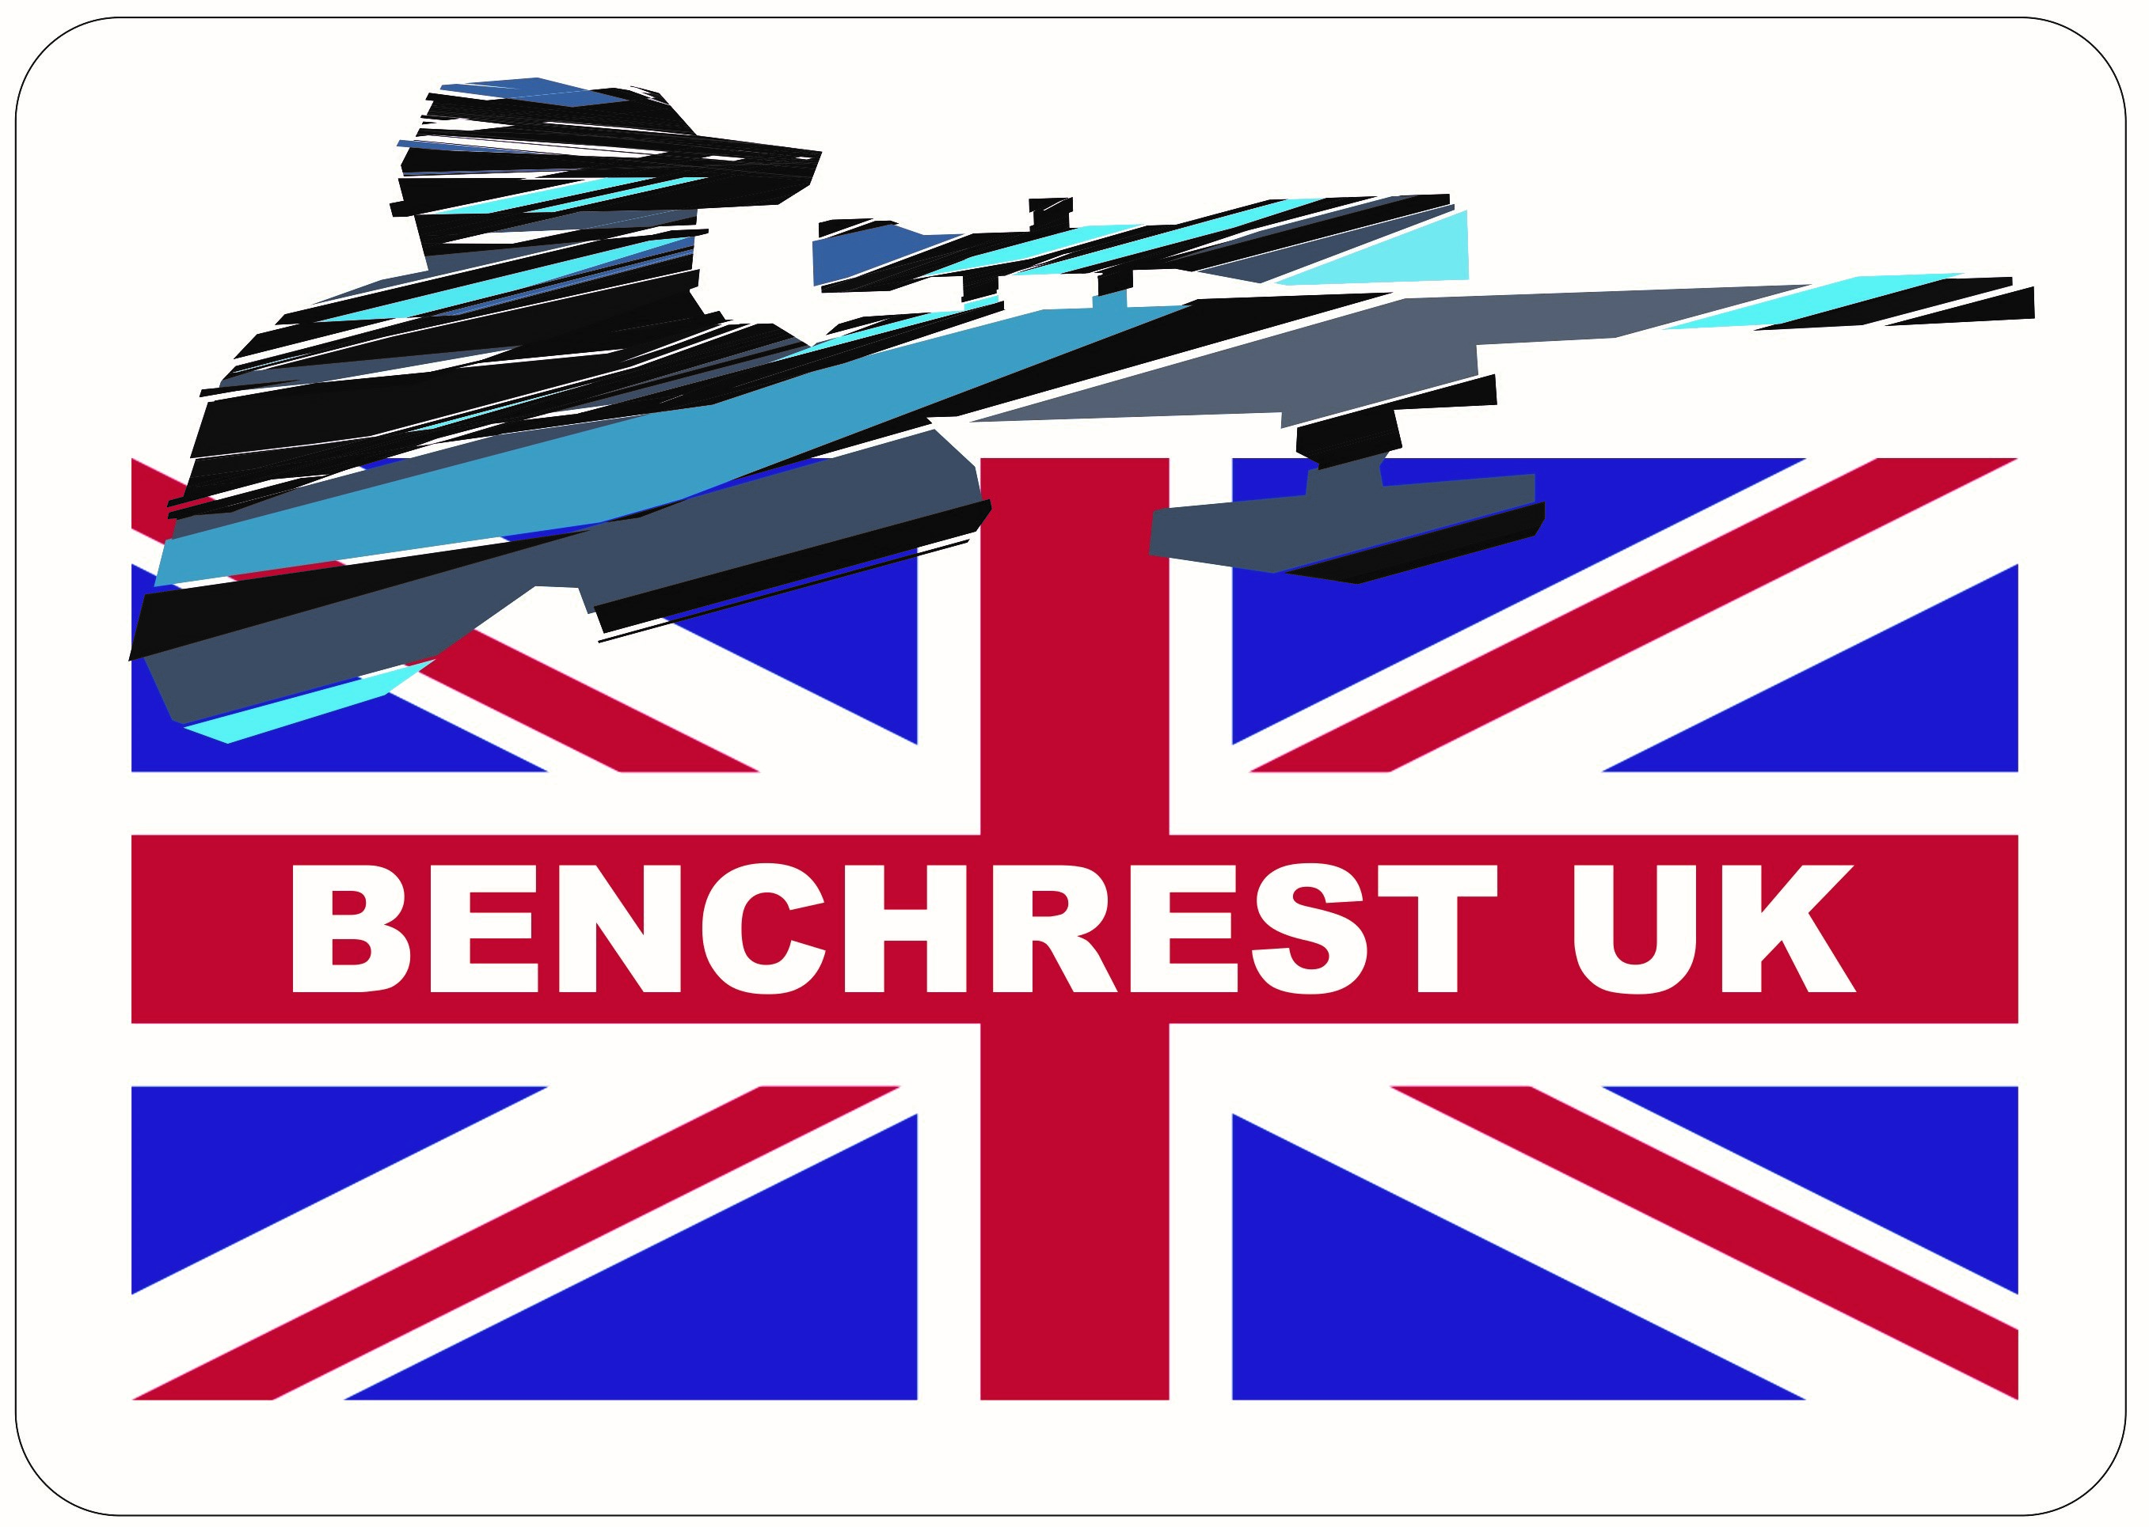
BENCHREST UK OPEN SHOOT AT GLEVUM 2023
7th 8th 9th APRIL

Name .
Address: .
Post Code; .
Telephone: Email .
Club .
Left / Right handed D.O.B (if under 18 at 31.3.2023) ________________

Benchrest UK Membership Number where applicable ______________

Competitions Available All Classes are shot outside

Rimfire
50mtr Heavy Varmint Yes / No
50mtr Light Varmint Yes / No

Air
25mtr Heavy Varmint Yes / No
25mtr Light Varmint Yes / No

Entry Fees: Non Benchrest UK Members
The entry fee for ONE competition is £20. for each additional competition entered the fee is a further £10.

Entry Fees: Benchrest UK Members
The entry fee for ONE competition is £10. for each additional competition entered the fee is a further £5

Total entry fee enclosed: £

Signed Date: .

The closing date for entries is 20th March 2023

Should entries be oversubscribed they will be accepted on a first come first served basis. restrictions may apply

Entry fees can be paid via the Benchrest UK webpage in store https://www.benchrestuk.com/?page_id=735

OR

Cheques should be made payable to Benchrest UK and returned with a completed entry form to the address below

Benchrest UK Open
Picketts Crest
Maresfield
East Sussex
TN22 3DP
Please do not enter more competitions than you can comfortably shoot within the dates/times available.

Please enclose a stamped self-addressed envelope or e-mail contact for squadding details.

Each match will consist of 3 (Three ) 25 Bull targets.

Please help us to help you, If you “share” equipment let us know as squadding cannot be changed on the day of the matches.

I am Sharing Equipment with ________________________

Date 7th 2023- April Practice 12 pm to 5pm
Date 8th 2023- April Main matches from 9am each day
Date 9th 2023 - April Presentation of medals etc

Address and Post code for the Range

Glevum Target and Sports Club
The Range
Upton Lane
Brookthorpe
Gloucester
GL4 0UT

Hotels

Centre Seven, Barnwood, GloucesterGL4 3HR
Sat Nav Directions: GL4 3HRWhat 3 Words: ///offer.thick.hotels
Directions:
Exit the M5 J11. Follow the A40 towards Gloucester, 1st roundabout take A417 towards Cirencester, at traffic lights take the first right and at mini roundbaout take the right. Next to the Wheatstone Inn.

