BENCHREST UK VIRTUAL AIR RIFLE OPEN SHOOT

Benchrest UK have decided to run a virtual Air rifle open shoot. This is for just for fun and there are no entry fees
Covid 19 has wreaked havoc on our planned competitions this year and many of our competitions have been cancelled due to the clubs not being able to open.
The idea behind this fun open shoot is to get people shooting again while still adhering to social distancing
This Is How It Works

- To take part Email me at webmaster@benchrestuk.com and tell me your full name, where you are going to shoot your targets from and what class / classes you wish to shoot eg LV or HV or Both
- Click on this link below and join the BENCHREST UK VIRTUAL AIR RIFLE WAILING WALL
- I will create a post on the wailing wall for each class you are going to shoot
Find the post / posts with your name as this is where you will post your photos of your targets in the comment section.
- 2 targets are to be shot for each class and must be shot on the 10th or 11th October between 9am and 6pm
- On the day of the shoot. Prepare your target with your Name , Class and Match number ie Joe Blogs HV Match 1 and put your target up
Prepare yourself to shoot and set up your equipment. Immediately before you shoot your detail photograph your unshot target. Shoot your 20min detail and as soon as you have finished the detail take a photograph of the shot target, score your target and post the pictures of both the unshot and shot target and your score in the comment section of your corresponding post on the Wailing Wall. You have 40 minutes from the time you started your detail to post your unshot target, shot target and score on the wailing wall. This time limit applies for each target you shoot in each class.

Link to Wailing Wall
https://www.facebook.com/groups/1189497278072208/
Example: UNDER YOUR NAME ON WAILING WALL HV OR LV
Under write a comment post your target
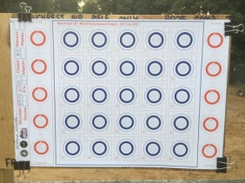
Start HV /LV
20min detail
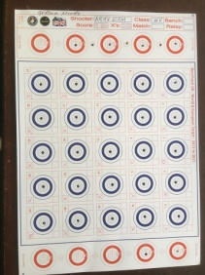
Take Picture of your target after you finish
Score (HV 250 -22x) and post under your start HV/LV comment within 40 minutes

You can view all the competitors targets on the Wailing Wall and keep up to date as people post their targets.
Official WRABF approved Targets can be purchased from the BENCHREST UK WEBPAGE
Link to Targets https://www.benchrestuk.com/?page_id=735&model_number=6648074

This is a fun competition to encourage more people to get involved in Benchrest Shooting.
The competition is 25m outdoor, 2 targets per class, targets must be official WRABF approved, these can be purchased from Benchrest Uk. 20min details and will be run under WRABF rules Please see the link below. The competition is open to all UK shooters. You are encouraged to shoot at your local club but if that is not possible or not a member of one, you can shoot wherever you normally shoot eg your back garden, but please adhere to the rules and be safe. Benchrest UK would like to thank Nick Schoonwinkle WRABF President for allowing us to hijack his great idea and run this shoot.

Link WRABF rules https://www.benchrestuk.com/wp-content/uploads/2018/12/WRABF-ERABSF-RULEBOOK-2013-2021.pdf

